Pune District Education Association’s
Seth Govind Raghunath Sable College of Pharmacy & Poly, Saswad
Activity Report
Title of the event: Alumni Meet
Date and Day: 02/03/2024, Saturday Time: 10.00 am – 02.00 pm
Venue: Open Auditorium
------------------------------------------------------------------------------------------------------------------------------------------
Alumni meet was held on 02nd March 2024 for 2005-2010 batches to facilitate, consolidate and coordinate alumni activities. The alumni meet was planned with objective to reconnect with the alumni and celebrate their success and various achievements. It was a day filled with excitement, emotions, and nostalgia as the alumni, both recent and older, came together to relive their college days and connect with their old classmates and teachers. The Alumni meet started arriving in college by 09.00 am and they were received by the registration team. The registration process was smooth and hassle-free, and the alumni were given a warm welcome by the organizing committee. The event began with lighting of the lamp & invoking the blessings of Goddess Saraswati. The Vice principal, Dr. Smita Pawar, accorded a warm welcome to all and apprised the alumni about the college changing infrastructure and proactive measures taken in recent times for the welfare of students. The coordinator of the Alumni Meet, Mr. Nilesh Bhosale, shared his memories of the college and welcomed everyone to the event. The meeting was graced by Dr. Pandit Shelke Principal Waghire College,Saswad & Mr.Rahul Darda, Managing Director, Brinton Pharmaceuticals Pvt .Ltd. D. Pharm passout alumni of 1995.
The most emotional moment of the event was when the alumni took a tour of their old classrooms and campus, reminiscing about their college days. After the tour, the alumni had a chance to reconnect with their old classmates and teachers over refreshments. It was heart-warming to see the excitement and joy on the alumni's faces as they shared their experiences and memories of their time at the college. It was indeed a great opportunity for the alumni to catch up with their old friends, network with each other, and build new connections. Many of them were seen clicking photographs with their former classmates and teachers, capturing the memories of the day. Alumni also interacted with the students and gave motivational talk regarding preparing for higher studies and placements. The present students asked many questions regarding placements and the alumni shared their views during interaction. The vote of thanks was given by coordinator, Mrs.Vishakha Gaikwad, she thanked the various organizers alumni members of the event. She also thanked the management of college for the support and guidance which has made Alumni Meet 2024 a grand success. The Alumni meet was co-ordinated by Mrs. S.B.Bathe, Mrs.V.S.Gaikwad & Mr.Nilesh Bhosale with support of all staff members & under the guidance of Principal Dr. R.S. Chavan.

Mrs.S.B.Bathe Mrs.V.S.Gaikwad Mr.N.R.Bhosale Dr. R. S. Chavan
Alumni Coordinator Alumni Coordinator Alumni Coordinator Principal

Photo Gallery (02/03/2024)

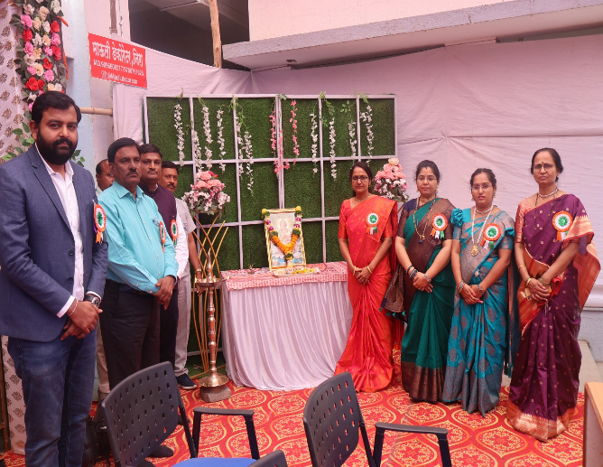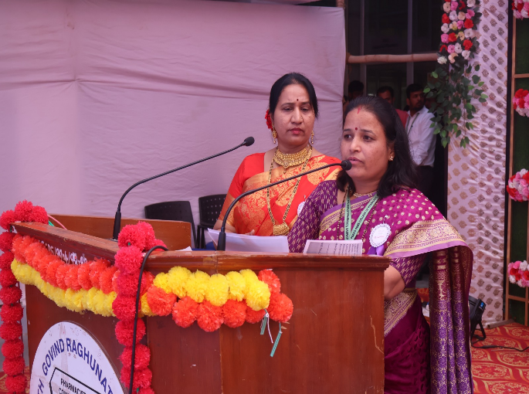
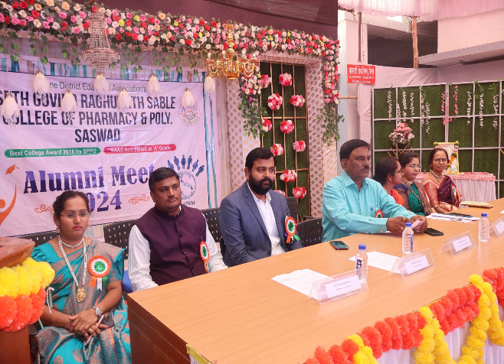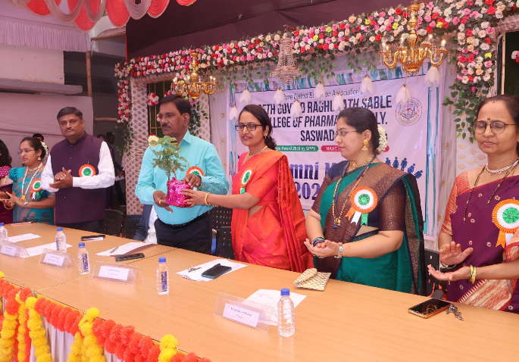
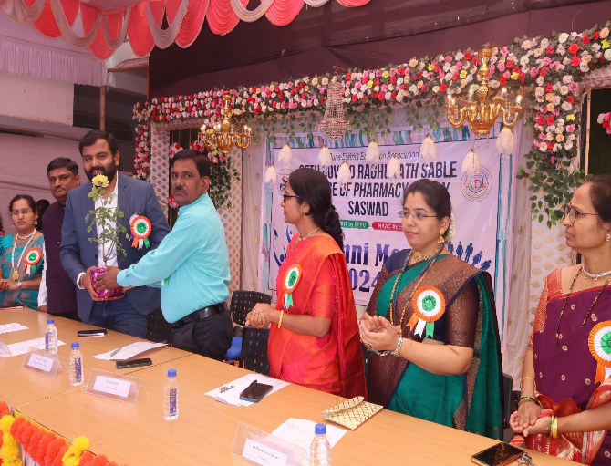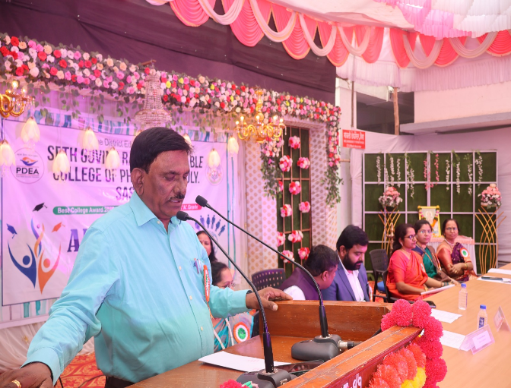

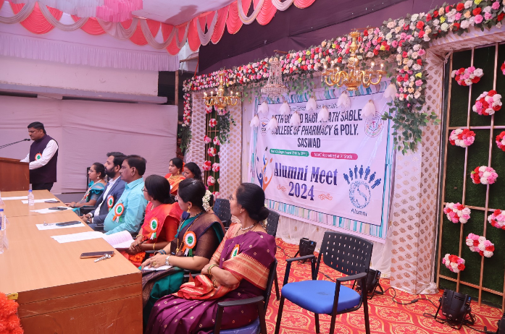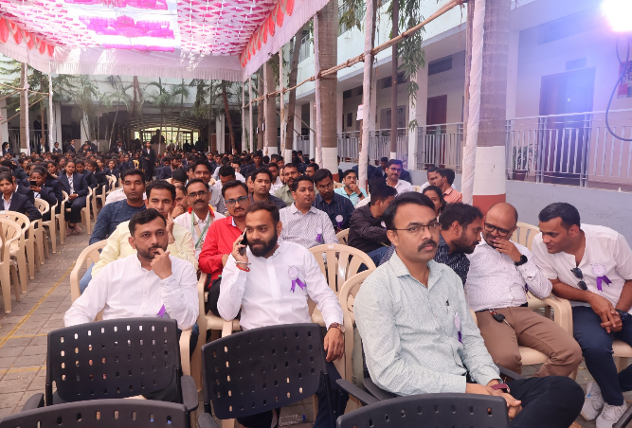
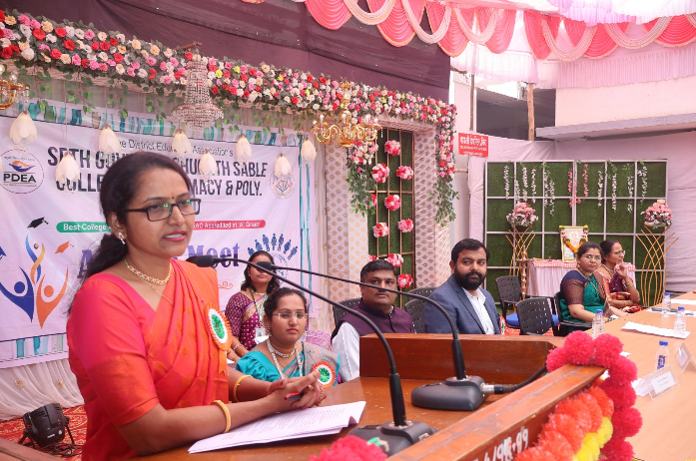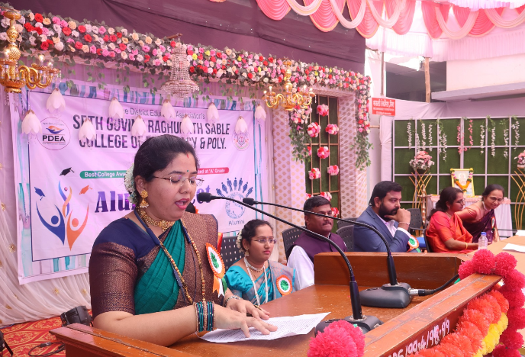
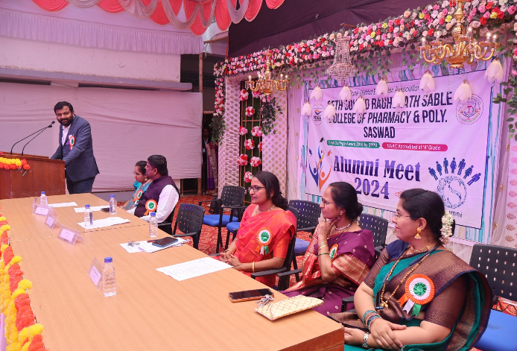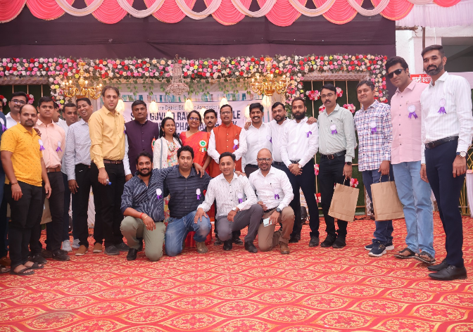
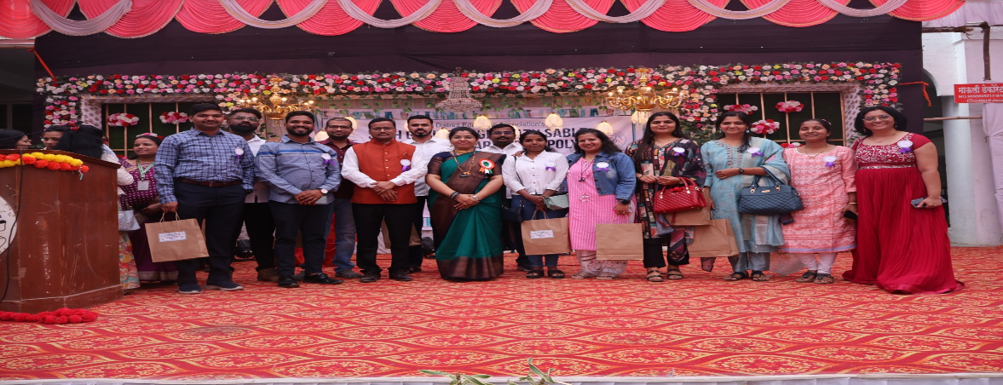

Dr. R. S. Chavan
Principal

